Operating System
LAB-9

Name : Muahammad Umer Ahmed
ID : IU05-0125-0092
PRIORITY CPU SCHEDULING ALGORITHM
For priority scheduling algorithm, read the number of processes/jobs in the system, their CPU burst times, and the priorities. Arrange all the jobs in order with respect to their priorities. There may be two jobs in queue with the same priority, and then FCFS approach is to be performed. Each process will be executed according to its priority. Calculate the waiting time and turnaround time of each of the processes accordingly.
PROGRAM
FCFS CPU SCHEDULING ALGORITHM

#include <stdio.h>
#include <conio.h>
#include <stdlib.h> // Required for system("cls")

int main()
{
int bt[20], wt[20], tat[20], i, n;
float wtavg, tatavg;

system("cls"); // Clears the screen in Windows

printf("\nEnter the number of processes -- ");
scanf("%d", &n);

for(i = 0; i < n; i++)
{
printf("\nEnter Burst Time for Process %d -- ", i);
scanf("%d", &bt[i]);
}

wt[0] = wtavg = 0;
tat[0] = tatavg = bt[0];

for(i = 1; i < n; i++)
{
wt[i] = wt[i - 1] + bt[i - 1];
tat[i] = tat[i - 1] + bt[i];
wtavg = wtavg + wt[i];
tatavg = tatavg + tat[i];
}

printf("\n\t PROCESS \tBURST TIME \t WAITING TIME\t TURNAROUND TIME\n");
for(i = 0; i < n; i++)
{
printf("\n\t P%d \t\t %d \t\t %d \t\t %d", i, bt[i], wt[i], tat[i]);
}

printf("\n\nAverage Waiting Time -- %f", wtavg / n);
printf("\nAverage Turnaround Time -- %f\n", tatavg / n);

getch();
return 0;
}

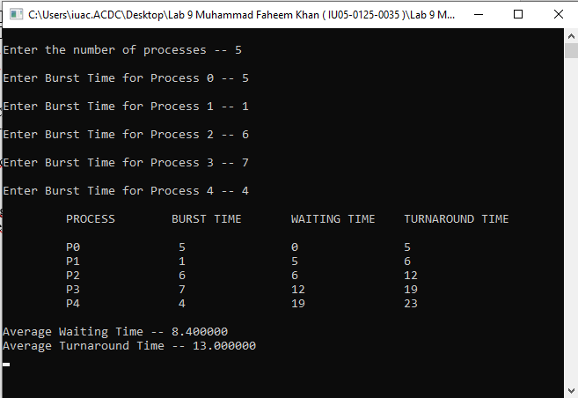

SJF CPU SCHEDULING ALGORITHM__________________________
#include <stdio.h>
#include <conio.h>
#include <stdlib.h> // Included for system("cls")

int main()
{
int p[20], bt[20], wt[20], tat[20], i, k, n, temp;
float wtavg, tatavg;

system("cls"); // Clears the console screen

printf("\nEnter the number of processes -- ");
scanf("%d", &n);

for(i = 0; i < n; i++)
{
p[i] = i;
printf("Enter Burst Time for Process %d -- ", i);
scanf("%d", &bt[i]);
}

// Sort processes by burst time (Shortest Job First)
for(i = 0; i < n; i++)
{
for(k = i + 1; k < n; k++)
{
if(bt[i] > bt[k])
{
temp = bt[i];
bt[i] = bt[k];
bt[k] = temp;

temp = p[i];
p[i] = p[k];
p[k] = temp;
}
}
}

wt[0] = wtavg = 0;
tat[0] = tatavg = bt[0];

for(i = 1; i < n; i++)
{
wt[i] = wt[i - 1] + bt[i - 1];
tat[i] = tat[i - 1] + bt[i];
wtavg = wtavg + wt[i];
tatavg = tatavg + tat[i];
}

printf("\n\t PROCESS \tBURST TIME \t WAITING TIME\t TURNAROUND TIME\n");
for(i = 0; i < n; i++)
{
printf("\n\t P%d \t\t %d \t\t %d \t\t %d", p[i], bt[i], wt[i], tat[i]);
}

printf("\n\nAverage Waiting Time -- %f", wtavg / n);
printf("\nAverage Turnaround Time -- %f\n", tatavg / n);

getch();
return 0;
}
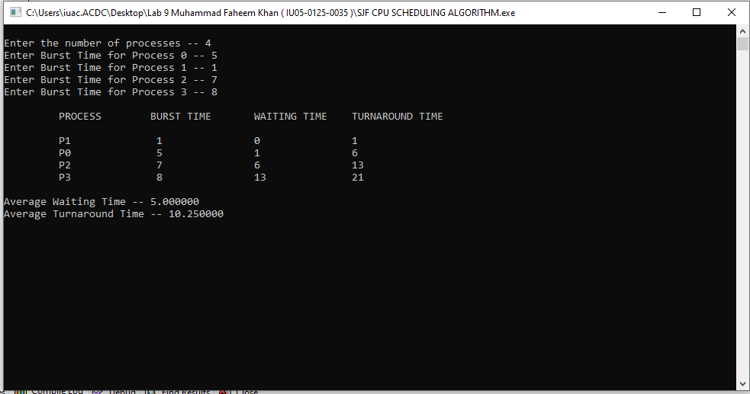

ROUND ROBIN CPU SCHEDULING ALGORITHM

#include <stdio.h>
#include <conio.h>
#include <stdlib.h> // Required for system("cls")

int main()
{
int i, j, n, bu[10], wa[10], tat[10], t, ct[10], max;
float awt = 0, att = 0, temp = 0;

system("cls"); // Clears the screen

printf("Enter the no of processes -- ");
scanf("%d", &n);

for(i = 0; i < n; i++)
{
printf("\nEnter Burst Time for process %d -- ", i + 1);
scanf("%d", &bu[i]);
ct[i] = bu[i];
}

printf("\nEnter the size of time slice -- ");
scanf("%d", &t);

max = bu[0];
for(i = 1; i < n; i++)
{
if(max < bu[i])
{
max = bu[i];
}
}

for(j = 0; j < (max / t) + 1; j++)
{
for(i = 0; i < n; i++)
{
if(bu[i] != 0)
{
if(bu[i] <= t)
{
tat[i] = temp + bu[i];
temp = temp + bu[i];
bu[i] = 0;
}
else
{
bu[i] = bu[i] - t;
temp = temp + t;
}
}
}
}

for(i = 0; i < n; i++)
{
wa[i] = tat[i] - ct[i];
att += tat[i];
awt += wa[i];
}

printf("\n\tPROCESS\t BURST TIME \t WAITING TIME\tTURNAROUND TIME\n");
for(i = 0; i < n; i++)
{
printf("\t%d \t %d \t\t %d \t\t %d \n", i + 1, ct[i], wa[i], tat[i]);
}

printf("\nThe Average Turnaround time is -- %f", att / n);
printf("\nThe Average Waiting time is -- %f\n", awt / n);

getch();
return 0;
}

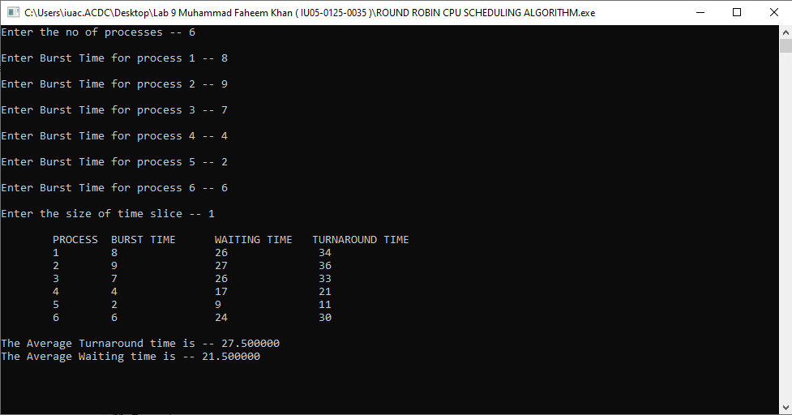

PRIORITY CPU SCHEDULING ALGORITHM

#include <stdio.h>
#include <conio.h>
#include <stdlib.h> // Added for system("cls")

int main()
{
int p[20], bt[20], pri[20], wt[20], tat[20], i, k, n, temp;
float wtavg, tatavg;

system("cls"); // Replaced non-standard clrscr()

printf("Enter the number of processes --- ");
scanf("%d", &n);

for(i = 0; i < n; i++)
{
p[i] = i;
printf("Enter the Burst Time & Priority of Process %d --- ", i);
scanf("%d %d", &bt[i], &pri[i]);
}

// Sort processes based on priority (lower value = higher priority)
for(i = 0; i < n; i++)
{
for(k = i + 1; k < n; k++)
{
if(pri[i] > pri[k])
{
// Swap process ID
temp = p[i];
p[i] = p[k];
p[k] = temp;

// Swap burst time
temp = bt[i];
bt[i] = bt[k];
bt[k] = temp;

// Swap priority
temp = pri[i];
pri[i] = pri[k];
pri[k] = temp;
}
}
}

wtavg = wt[0] = 0;
tatavg = tat[0] = bt[0];

for(i = 1; i < n; i++)
{
wt[i] = wt[i - 1] + bt[i - 1];
tat[i] = tat[i - 1] + bt[i];

wtavg = wtavg + wt[i];
tatavg = tatavg + tat[i];
}

printf("\nPROCESS\t\tPRIORITY\tBURST TIME\tWAITING TIME\tTURNAROUND TIME\n");
for(i = 0; i < n; i++)
{
printf("%d \t\t %d \t\t %d \t\t %d \t\t %d \n", p[i], pri[i], bt[i], wt[i], tat[i]);
}

printf("\nAverage Waiting Time is --- %f", wtavg / n);
printf("\nAverage Turnaround Time is --- %f\n", tatavg / n);

getch();
return 0;
}

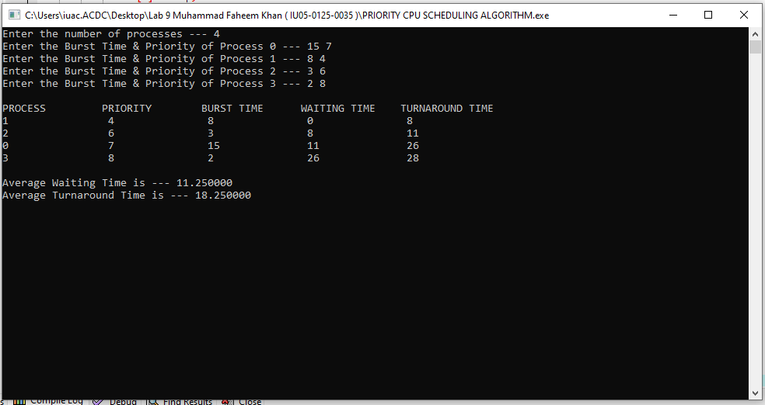

Task 2 MULTILEVEL QUEUE CPU SCHEDULING ALGORITHM

DESCRIPTION
Multi-level queue scheduling algorithm is used in scenarios where the processes can be classified into groups based on property like process type, CPU time, IO access, memory size, etc. In a multi-level queue scheduling algorithm, there will be 'n' number of queues, where 'n' is the number of groups the processes are classified into. Each queue will be assigned a priority and will have its own scheduling algorithm like round-robin scheduling or FCFS. For the process in a queue to execute, all the queues of priority higher than it should be empty, meaning the process in those high priority queues should have completed its execution. In this scheduling algorithm, once assigned to a queue, the process will not move to any other queues.
#include <stdio.h>
#include <conio.h>
#include <stdlib.h>

int main()
{
int p[20], bt[20], su[20], wt[20], tat[20], i, k, n, temp;
float wtavg, tatavg;

system("cls");

printf("Enter the number of processes --- ");
scanf("%d", &n);

for(i = 0; i < n; i++)
{
p[i] = i;
printf("Enter the Burst Time of Process %d --- ", i);
scanf("%d", &bt[i]);
printf("System/User Process (0/1) ? --- ");
scanf("%d", &su[i]);
}

for(i = 0; i < n; i++)
{
for(k = i + 1; k < n; k++)
{
if(su[i] > su[k])
{
temp = p[i];
p[i] = p[k];
p[k] = temp;

temp = bt[i];
bt[i] = bt[k];
bt[k] = temp;

temp = su[i];
su[i] = su[k];
su[k] = temp;
}
}
}

wtavg = wt[0] = 0;
tatavg = tat[0] = bt[0];

for(i = 1; i < n; i++)
{
wt[i] = wt[i - 1] + bt[i - 1];
tat[i] = tat[i - 1] + bt[i];

wtavg = wtavg + wt[i];
tatavg = tatavg + tat[i];
}

printf("\nPROCESS\t\tSYSTEM/USER PROCESS \tBURST TIME\tWAITING TIME\tTURNAROUND TIME\n");
for(i = 0; i < n; i++)
{
printf("%d \t\t %d \t\t\t %d \t\t %d \t\t %d\n", p[i], su[i], bt[i], wt[i], tat[i]);
}

printf("\nAverage Waiting Time is --- %f", wtavg / n);
printf("\nAverage Turnaround Time is --- %f\n", tatavg / n);

getch();
return 0;
}

